RSPO Smallholder Support Fund
Smallholder Impact Project

NOTE: Applicants are advised to refer to the RSSF Funding Request Application Guidelines document when filling up this form.
- Applicant: General Information
1.1 Name of the Organization
1.2 Contact Person
Name
Position
Address
Country
Telephone
Mobile Phone
Email

- Project: General Information
2.1 Project title
2.2 Country(ies) of implementation
2.3 Supporting organization (if any)
2.4 Project period | Proposed Start Date:
 | Expected Project End Date:
2.5 Duration of the project (months)
2.6 Total budget | In Local Currency:
 | In USD / EUR / MYR / IDR Currency:
2.7 Contribution requested from RSPO | In Local Currency:
 | In USD / EUR / MYR / IDR Currency:
2.8 Date of submission
2.9 Brief Project Description:

- Background Information of Organization
3.1 Name of the Organization
Acronym (where relevant)
3.2 Address
3.3 Name of the Head of the Organization
3.4 Type of Organization
3.5 Legal Status
3.6 Date organisation formed
3.7 Number of staff
3.8 Average annual budget / turnover over the last three years (specify or indicate range) | [ below USD20,000]  [USD20,000-50,000]  [USD50,000-100,000]  [USD100,000-500,000]  [> USD500,000]
3.9 Recent activities or projects that best characterise your organisation (max. three) | 1.
 | 2.
 | 3.
3.10 Key references, e.g. donors or partners (max. three; provide name, organization, telephone nr and/or email address) | 1.
 | 2.
 | 3.

- Description of Project Proposal
Provide the following basic information that will allow RSPO to understand in broad terms what the proposed project is about, its relevance and justification, and the expected main results. This information should allow RSPO to make a first assessment.
4.1 SUMMARY DESCRIPTION OF PROJECT, DESCRIBING MAIN ACTIVITIES TO ACHIEVE THE RESULTS (MAX. 250 WORDS)
Click here to enter text.

4.2 PROJECT’S MAIN OBJECTIVE IN ONE SENTENCE (FORMULATION MUST BE IN LINE WITH RSPO MISSION)
Click here to enter text.

4.3 DETAILED JUSTIFICATION OF THE PROJECT (PROBLEM, OPPORTUNITY, POLICY RELEVANCE, ETC)
Click here to enter text.

4.4 EXPECTED RESULT
Please provide in detail the expected results in one sentence each per statement. Please provide measurable indication of result
4.5 DESCRIPTION PROJECT APPROACH OR MECHANISMS
Click here to enter text.

4.6 PARTNERSHIPS TO IMPLEMENT THE PROJECT (INCLUDE CONTACT DETAILS, ROLES AND CONTRIBUTION TO THE PROJECT)
Click here to enter text.

IMPORTANT
Additionally, application for Smallholder Impact Fund must be supported with the following information:
1. Results and Main Activities
2. Budget Details
3. Monitoring Scheme
4. Workplan / Timeline

Please refer the description in Annex 1 as guidance to prepare the above additional information.

ANNEX 1

ANNEX 1

1. Results and Main Activities
Provide a list of expected results and describe main activities per expected result. Specify not more than 5 main activities per expected result. This may require some clustering of your initial long-list of activities.

Then also indicate the time frame, i.e. when each main activity will be implemented. For projects with duration of less than 6 months, we expect main activities to be planned per month. For projects with duration of more than 6 months, we expect main activities to be planned per period of 3 months (quarter).

Please note that activities that communicate the results of the project to other stakeholders and the wider public, as well as activities that enable to share lessons learned with relevant stakeholders, are much appreciated.

This includes a description of the main activities, with details as regards what will be done at what stage, where and how. In doing so, main activities are as much as possible specified in terms of quantities and timeframe.

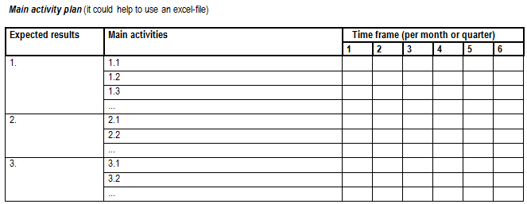
Applicants may use Excel spreadsheet format to develop the Expected Result, Main Activities, Timeframe, etc.

2. Budget Details
Provide a break-down of the budget per main activity as identified above. Also, indicate, per result and main activity, the different sources of funding. Specify other cost items for issues that cannot be directly linked to an expected main result or activity.

A more specific budget, per budget item, should be provided as an annex, preferably also in Excel spreadsheet format.
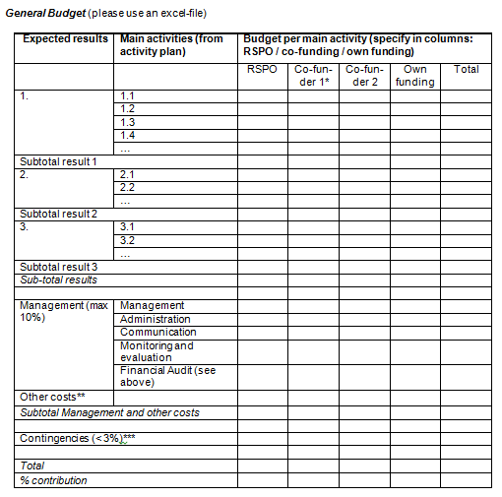
Applicants may use an excel format to develop the Expected Result, Main Activities, Budget per Main Activities etc.

3. Monitoring Scheme
Monitoring is an important element in the RSPO Smallholder project. For each of these monitoring activities is being made of indicators in order to assess whether there is progress. For each initiative, the following elements are to be considered:
- Monitoring indicator framework
- Monitoring plan
- Reporting and evaluation

Definitions
Indicators are variables that measure to what extent or degree certain project objectives is being realised. Indicators should as much as possible meet SMART criteria, by being:
• Specific: is well defined, no doubts about what is meant;
• Measurable: allows quantification if possible;
• Accurate: shows a clear linkage with programme elements;
• Realistic: can be measured, cost-effective and timely;
• Time-bound: allows differences to be observed within the programme period.
However, in some cases it is useful to formulate qualitative indicators.

Output indicators are associated with the level of expected results. Outputs are the products or services delivered by the project to the target groups. They result from the execution of the project activities.

Outcome indicators are associated with the level of specific / project objective. Outcomes are the end-of-project situation/s to which outputs contribute. The project is held responsible to realise the outcomes / objectives.

Impact indicators are associated with the level of overall objectives. Impacts are the final benefits generated for people and nature. The project will contribute to these benefits (impacts) but cannot be held responsible for realising them because other factors are also involved (refer to assumptions).
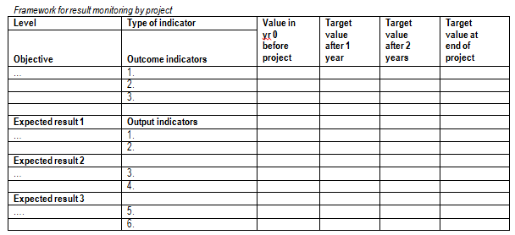

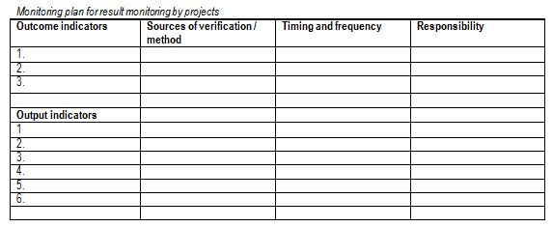
Applicants may use an excel format to develop the matrix

4. Workplan / Timeline
Provide a clear breakdown of all main activities, activities based on the target timeline in reaching towards the results. This should be aligning through the 3 above mentioned items no. 1 to 3. Preferably Gantt Chart format in an Excel sheet.

Producer, Processor, Trader, Importer, Industry, Retail, Finance, NGO, other
Association, Foundation, Limited Company, Public Listed Company, etc

