Independent Smallholder - Land Use Risk Identification
Preamble
The RSPO, in consultation with the HCSA Steering Group, intends to develop a simplified combined HCV-HCS approach to identify and protect HCS forests as well as existing HCV areas. Using this approach will allow for ISH group members to comply with the Criteria 4.1 and 4.3 of the RSPO Independent Smallholder Standard (ISH) 2019 which is aligned with the new HCS requirements in the RSPO P&C 2018.

The Independent Smallholder No Deforestation Task Force (IS-NDTF) will be established to oversee the development of a simplified combined HCV-HCS approach for independent smallholders.

In the meantime, independent smallholders are not allowed to clear any primary forests, or any areas required to protect or enhance HCVs and HCS forests, as committed by signing the Smallholder Declaration. Until the simplified combined HCV-HCS approach and tool for independent smallholders is available, new planting or expansion of existing plots will only be permitted in “Low Risk” areas.

As an interim measure, the Independent Smallholder - Land Use Risk Identification (IS-LURI) was developed by the RSPO Secretariat and will be a requirement for ISH group members intending to clear plots for new planting or expansion of existing plots. The IS-LURI is in place as a measure to identify “Low Risk” and “Risk” areas while the simplified combined HCV-HCS tool is being developed. The flow chart below indicates the process that will be required to identify if an independent smallholder can carry on new planting or expansion of existing plots.

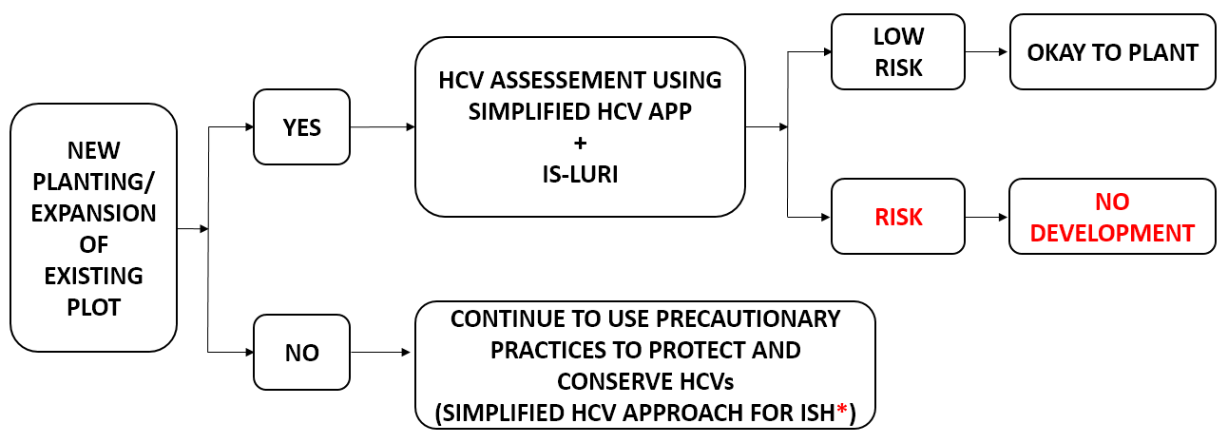

All “Risk” areas identified through the IS-LURI (for Independent Smallholder Member intending to clear plots for new planting or expansion of existing plots) must not be developed until the simplified combined HCV-HCS approach and tool for independent smallholders is published and ready for use.

*Guidance for Independent Stallholders on Managing HCVs in Established OP Plantation can be referred to using this link: https://rspo.org/resources/archive/569
Reporting Template: Independent Smallholder - Land Use Risk Identification
- Group Information
Name of RPSO Independent Smallholder (ISH) Group
RSPO membership number
Date of joining RSPO
Location of ISH Group
Total area of ISH Group (Ha)
Details of ISH Group undergoing new planting or expansion of existing plots |  | To be completed in Annex 1
Georeferenced vector data (Shape Files) indicating the legal boundaries of management units |  | Section 2.1 & Submission in a folder
Land title deed |  | Attach if Available / Not Available (Indicate)
HCV assessment*  (to attach with submission) | Date conducted
 | Date report issued

* Note: To attach the relevant report(s) that was used as reference(s) for the LURI.

- Results
The independent smallholder intending to clear plots for new plantation or expansion of existing plots will be required to submit maps depicting the proposed new planting or expansion boundaries. The RSPO maps its members’ oil palm plantations by using polygon shapefiles. Therefore, independent smallholders who wish to expand their plots will have to submit polygon shapefiles. A polygon is a closed shape defined by a connected sequence of X and Y coordinates, where the first and last coordinates are the same. Polygons present information on location, length and size of the area of interest. Hence, it is suitable to be used for the IS-LURI. Please refer to the guidance document on steps to create a new polygon shapefile.

  - Polygon Data Table
No | Plot ID | Clearly outlined polygon of ISH Concession: | Polygon of HCV area within ISH Plot | Polygon of ISH plot intended for new planting or expansion clearly outlined
1
No | Plot ID | Clearly outlined polygon of ISH Concession: | Polygon of HCV area within ISH Plot | Polygon of ISH plot intended for new planting or expansion clearly outlined:
2
3
No | Plot ID | Clearly outlined polygon of ISH Concession: | Polygon of HCV area within ISH Plot | Polygon of ISH plot intended for new planting or expansion clearly outlined:
4
5

2.2 Independent Smallholder - Land Use Risk Identification
The land cover classification and ID in the table below serve as examples of land cover class and are not fixed nor limited to those provided. Land cover class and ID may be added and/or removed based on the classification found in the HCV assessment of the respective area. This section intends to identify the status of the land before new planting or expansion is carried out. The categorization of risk according to the land cover class are as listed below:
- Low Risk
  - Bare land/ no vegetation existed.
  - Pasture - Field covered with grass/ herbage that is suitable for grazing by livestock
  - Agriculture or monocrop tree plantations which have not been abandoned > 3 years.
e.g.: Palm Oil/ Rubber/ Banana/ Corn
  - Infrastructure - Roads/ Bridges
- Risk: Any other area apart from those identified as ‘Low Risk’ are considered as Risk area.
ID | Land cover class | Area (Ha) | Risk category  (Low Risk or Risk) | Total area (Ha)
 |  |  |  | Low Risk | Risk
LR1 | Bare land |  | Low Risk
LR2 | Oil Palm / Rubber plantation |  | Low Risk
LR3 | Infrastructure |  | Low Risk
R1 | Secondary Forest |  | Risk
R2 | Shrub |  | Risk
HCV | HCV area |  | Risk
HCVMA | HCV management area |  | Risk
CSA | Conservation |  | Risk
Grand Total

2.3 Geo-Tagged Field Photographs of Low Risk Areas
Plot ID | North | South | East | West
Shape File ID:
Land Cover Class:
Coordinates:
Shape File ID:
Land Cover Class:
Coordinates:
Plot ID | North | South | East | West
Shape File ID:
Land Cover Class:
Coordinates:
Shape File ID:
Land Cover Class:
Coordinates:

2.4 Final Independent Smallholder - Land Use Risk Identification
Insert image of Polygon which indicates location of Geo-Tagged Field Photographs. This Polygon should have clear indication of “Low Risk” areas based on the Independent Smallholder Land Use Risk Identification (IS-LURI).

ID | Low Risk Area (Ha) | Remarks (if any)
TOTAL

Annex 1: Details of ISH Group Member intending for new plantation or expansion of existing plots

No. | Name of Farmer | Total size of plot (Ha) | Plot ID | Status of land | Size of Land Intended for Expansion (Ha) | Remarks
 |  |  |  | Forest
 |  |  |  | Rice
 |  |  |  | Oil Palm
 |  |  |  | Rubber
 |  |  |  | Fruit Trees
 |  |  |  | Others (Specify)

